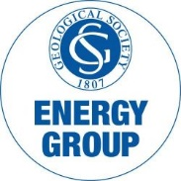
The Energy Group Medal
Nomination

The Medal
The Energy Group Medal is an annual award presented to individuals with a geoscience background who have made an outstanding contribution to the energy industry. The winner will be presented with the medal at the Energy Group annual dinner 2024.

Nominee
…………………………………………….
Proposed By (please add name in BLOCK CAPITALS after signature)
…………………………………………….
Supported By (please add name in BLOCK CAPITALS after signature)
…………………………………………….
Supporting Statement (of no more than 500 words):

